Library and Information Science Symposium Day

NEW ROLES FOR LIBRARIANS

Librarians’ Experiences of the Teaching Role

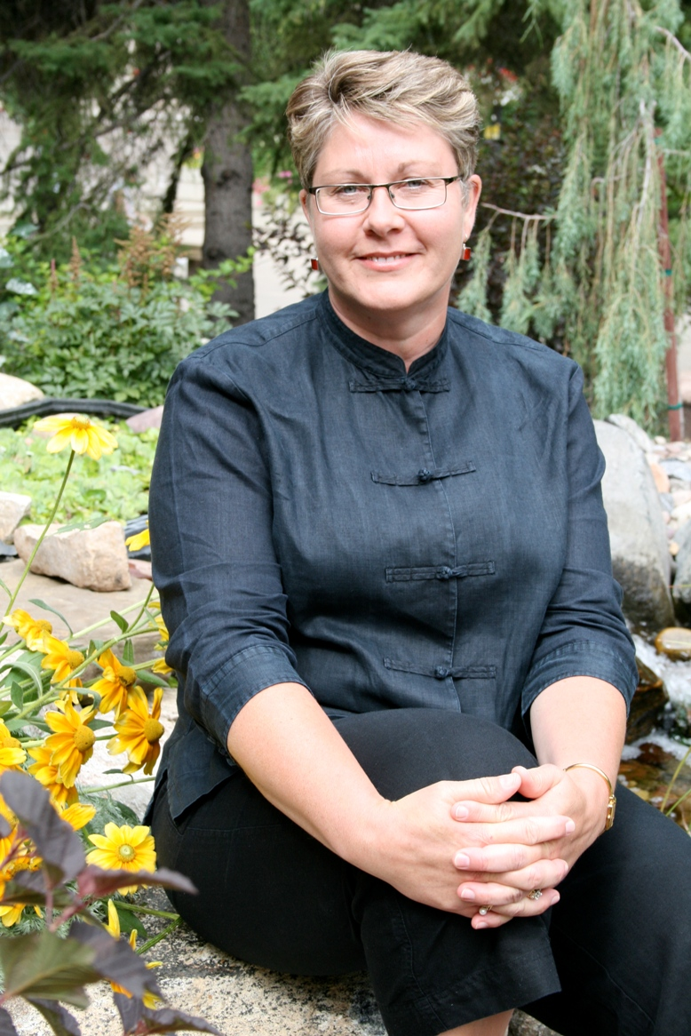
Friday, April 3, 2009
10:00 AM -- 11:30 AM, Room 323
Free and Open to the Public; light lunch provided
Dr. Heidi Julien is Associate Professor in the School of Library and Information Studies, University of Alberta. Heidi has a Bachelor of Education and Master of Library and Information Studies from the University of Alberta, and a Ph.D. from the University of Western Ontario. Previously, she held academic appointments at Dalhousie University in Halifax, Canada, and at Victoria University of Wellington, New Zealand. Her research interests include human information behavior, information literacy, and information policy; this work is funded primarily by the Social Sciences and Humanities Research Council of Canada. Heidi has served as President of the Canadian Association for Information Science, and as Director (External Relations) for ALISE. She serves currently on the Conference Committee for the 2009 Annual ASIS&T Conference, and is Editor of the Canadian Journal for Information and Library Science.

Rutgers University
School of Communication, Information and Library Studies (SCILS)

A Presentation by Dr. Heidi Julien

Librarians’ Experiences of the Teaching Role

In post-industrial societies, information literacy skills are central to “literacy” and to quality of life in general. Since librarians play a key role in information literacy instruction, the study which is the focus of this talk examines “readiness” of library staff to deliver successful instruction; it is based on a context in which there is a paucity of training opportunities for librarians during their professional preparation, ambivalent attitudes by library managers about the value of such training, and ambiguous attitudes on the part of instructional librarians about their teaching role. This multi-phase national study has explored librarians’ experiences of their teaching role. The study results are expected to contribute to improvements in instructional work, with a view to improving outcomes of information literacy instruction.

For further information, please contact Ya-Ling Lu (yalinglu “at” rci.rutger.edu).
Library and Information Science Symposium Day

NEW ROLES FOR LIBRARIANS

Knowledge management in libraries: Case study: Knowledge management in the public library of Vlissingen
(The Netherlands)

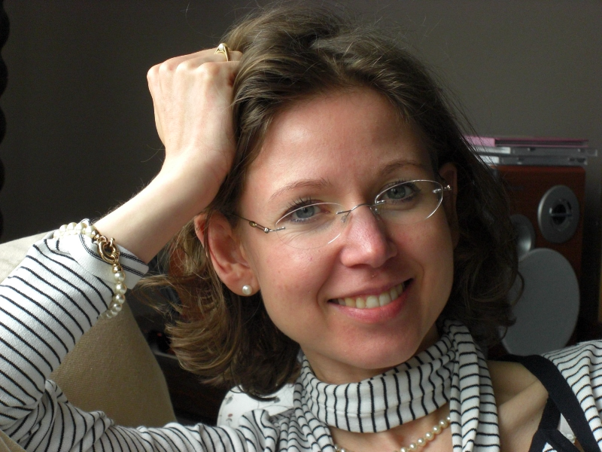
Karolien Selhorst holds a Master’s degree in Translation (English-Spanish) and a Master’s degree in Information and Library Sciences (University of Antwerp) and currently works as digital library manager/knowledge manager in the public library of Vlissingen (Holland). As an independent consultant, Karolien advises organisations on knowledge management, change management and web2.0-tools and provides trainings for information professionals and librarians. She is also chief editor of her own magazine ‘Digitale Bibliotheek’ and a freelance journalist for ‘Intellectueel Kapitaal’, a knowledge management magazine.

Friday, April 3, 2009
12:00 -- 1:30 PM, Room 323
Free and Open to the Public; light lunch provided
Rutgers University
School of Communication, Information and Library Studies (SCILS)

A Presentation by Karolien Selhorst
Knowledge management in libraries: Case study: Knowledge management in the public library of Vlissingen (The Netherlands)

“Libraries excel in managing information and knowledge captured in books and documents, but they fail in locating and managing the knowledge potential
in the heads of their own people.”

The public library of Vlissingen is very ambitious in providing the best possible service to its users. In order to successfully realise this goal, the library wants to make maximum use of the hidden knowledge in the heads of library workers. In the past, however, the library had been experiencing several problems related to the exchange of knowledge between library staff members and between library workers and library customer. The solution was found in the field of knowledge management, still a fairly new discipline in the Dutch public library sector.

Directions to SCILS:
For directions to SCILS, please visit the SCILS website. Parking is often available at meters on the street on Fridays. Rutgers University buses are free. Parking anywhere downtown New Brunswick is an option -- take the RU bus to College Ave. and exit the bus near the SCILS building on George St. or in front of the student center on College Ave.
For further information, please contact Connie Pascal (connie_pascal "at" yahoo.com).

